Vernacular Names: Ironwood | Scientific Name: Casuarina equisetifolia L.
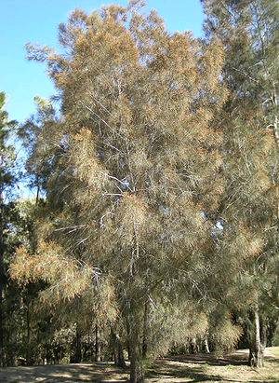 | 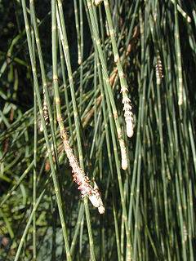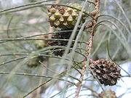
Full tree form | Details of leaf, flower, & fruit
Native or Introduced: Probably native, although some consider it an introduced and invasive species.

Description: They are evergreen shrubs and trees growing to 35 m tall looking like a wispy conifer. The foliage consists of slender, much-branched green to grey-green twigs bearing long segmented needle-leaves in whorls of 5–20. The flowers are produced in small catkin-like inflorescences; the male flowers in simple spikes, the female flowers on short peduncles. Most trees have both types of flowers, but a few are either male or female only. The fruit is a woody, rough, oval structure superficially resembling a conifer cone made up of numerous carpels each containing a single seed with a small wing. This tree cannot easily be confused with any other, except Tamarisk, which is not recorded from Chagos.

Habitat: Coastal, especially a pioneer species on freshly deposited sand. Tree roots hold the soil and sand against erosion by the sea for a time.

Human uses: The plants are very tolerant of windswept locations, and are widely planted as wind-breaks, although usually not in agricultural situations. The wood of this tree is used for shingles, fencing, and is said to make excellent, hot burning firewood. The gum exuded from some casuarinas is edible.

Significance: Considered by some an invasive tree weed and can take over new areas of sand e.g. Point Marianne sandbanks, but also a valuable shoreline protector from wave erosion if large trees growing close together. The shed needle leaves make a deep mulch bed in which it would seem other species are unable to grow.

Propagation: From seed.

